Assignment(2)

PYTHON AND MACHINE LEARNING

Name : Tanusha Kutakula

Trainer Name : Harshee Pitroda

Course Name : Python and ML

Date : 24 May

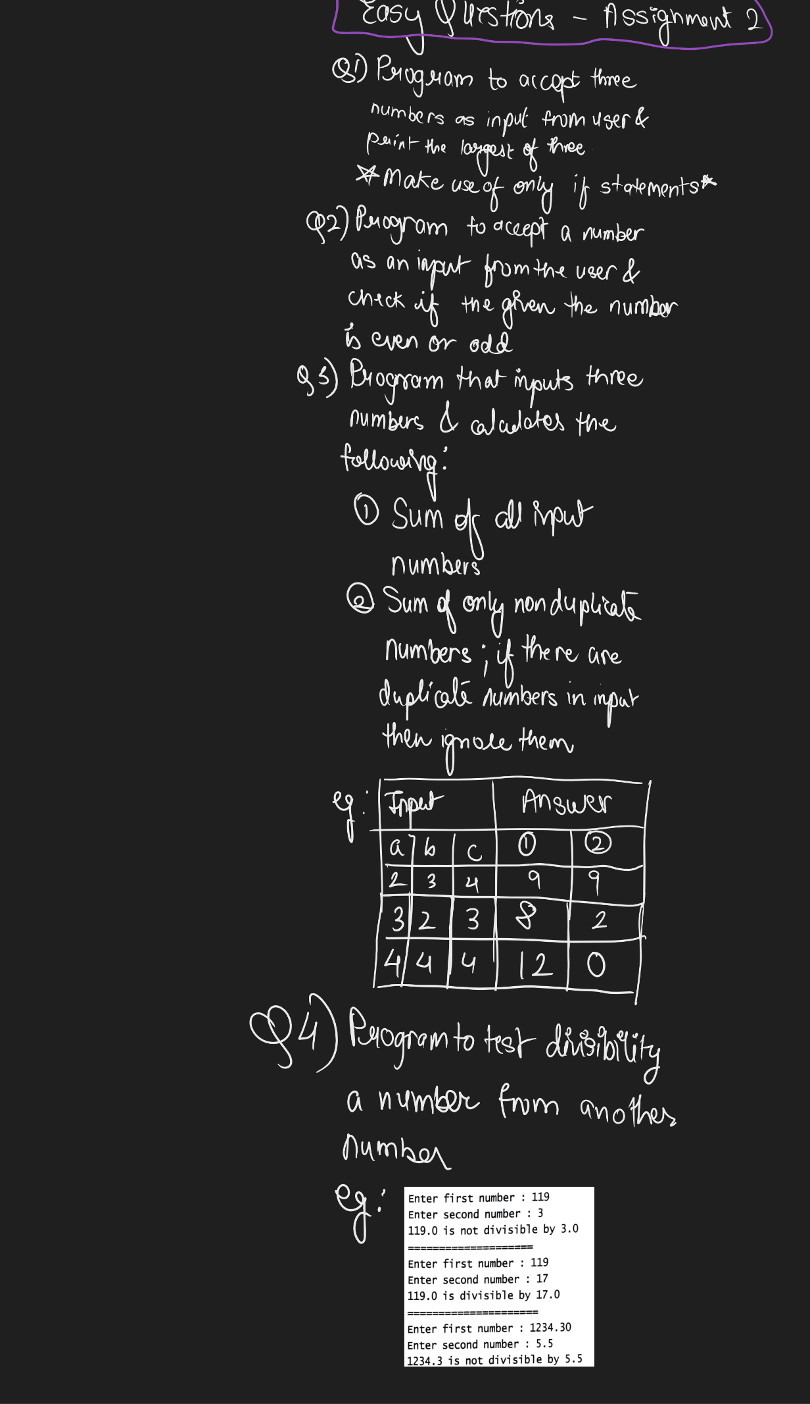

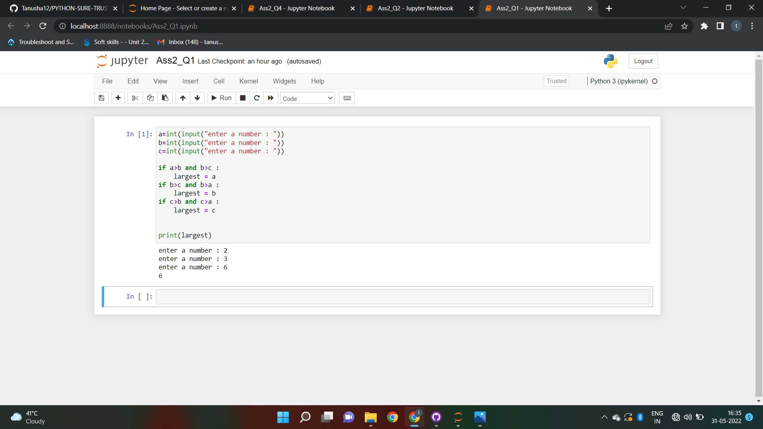**Answer-1 :**

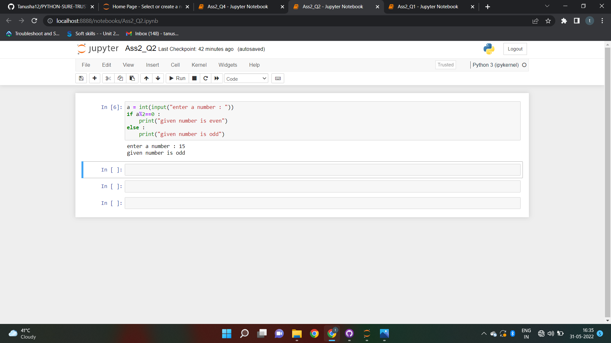**Answer-2:**

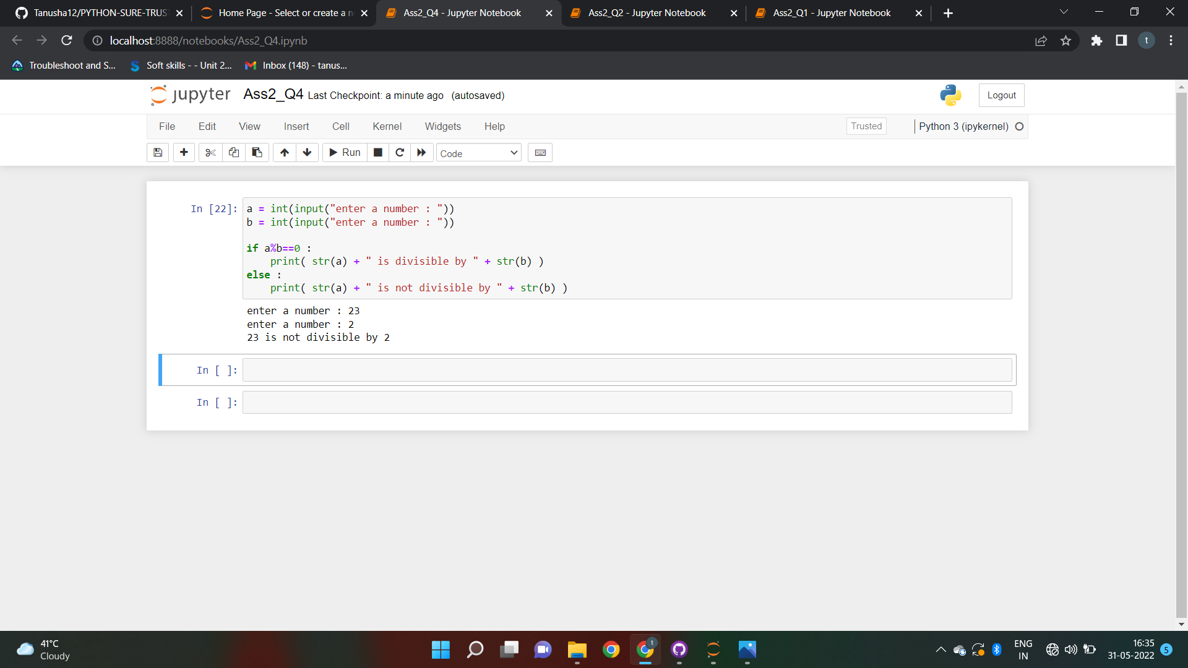**Answer-4:**

**Answer-3:**

